Table of Content

Introduction 3

Main Features 3

Forming a Development Team 3

Preliminary Research 3

Brainstorming 3

Research – Web Market Analysis 3

Description 3

Technical Requirements 4

Personas 4

Use Cases 4

Activity Diagram 4

Entities (20 marks) 4

Content Plans (10 marks) 4

Prototypes (20 marks) 4

Class Diagram (20 marks) 5

Implementation - Developing the Agile Plan (20 marks) 5

Conclusion 5

Team Contributions 6

References 6

# Introduction

There are many obstacles in the way of creating a successful tech start-up, from putting together a competent team to locating the best resources and mentors. A recurrent bottleneck persists despite the rise of digital entrepreneurs: a dearth of easily available platforms that promote productive teamwork and deep connections.

A networking and collaboration tool created especially for tech start-ups is called Co-Lab Connect. To link founders with possible co-founders, team members, and mentors, the app uses AI-driven matchmaking. To facilitate smooth project management, it also offers a virtual collaboration area furnished with resources like task boards, video conferencing, and shared code repositories. With the help of its creative Skill swap feature, users may swap knowledge (for example, coding skills for design help), fostering a vibrant community of support and development.

In keeping with the goal of supporting high-tech start-ups, Co-Lab Connect empowers entrepreneurs to strengthen teams, encourage innovation, and expedite communication to address important pain issues. Start-ups will have access to resources through this platform that are necessary for expansion and sustainability in the cutthroat tech sector.

# Main Features

# Forming a Development Team

Development Team

Stated below are the names, roles and skill required for this project

|  |  |  |
| --- | --- | --- |
| Name | Role | Skills |
| Chiagozie Maduemesi | Product Owner | Business strategy, stakeholder communication |
| Faith Okunola | Content Strategist and researcher | Market analysis, persona creation, content writing |
| Onolemen Omokhuale | UI/UX Designer | Figma, prototyping, user research |
| Shresta Rapol | Back End Developer | Database design, server-side development |
| David Carter | Full Stack Developer | Node.js, React.js, MongoDB, API development |
| Mese Lee | Q/A Engineer | Testing frameworks, front-end coding, documentation |
| Oneal Williams | Scrum Master | Agile processes, team facilitation |

The Development team is presented below

|  |  |  |
| --- | --- | --- |
| Role | Team Members | Task |
| Porduct Owner | Chiagozie Maduemesi | - Represents the customer and stakeholder interests |
|  |  | - Prioritizes features and manages the product backlog. |
|  |  | - Defines the vision and goals for Co-Lab Connect. |
| Scrum Master | Oneal Williams | - Facilitates sprint planning, reviews and retrospectives and ensures the team follows agile principle. |
| Brainstorming | Onolemen Omokhuale, Shresta Rapol, Faith Okunola, David Carter. | - Generating ideas for user experience and technical implementation |
| Research | Faith Okunola, Omokhuale Onolemen | -Findings on already existent platforms and collaboration tools, skill exchange platform, AI algorithm. |
| Business Model | Chiagozie Maduemesi, Faith Okunola | Creating sustainable business strategy aligning with the startup goals as well as defining revenue streams. |
| Market Analysis and Personas | Faith Okunola, Omokhuale Onolemen | -Developing personas for target audience and also analyzing market needs. |
| UseCases | Mese Lee, Shresta Rapol | - Defining user interactions with match making and collaboration tools. |
|  |  | -Creation of flowcharts for document use. |
| Entity Relationship Diagram | Shresta Rapol, David Carter | -Design the database schema users, connections, task and skill exchanging. |
|  |  | -Ensuring scalability for future growth. |
| Class Diagram | Shresta Rapol, Mese Lee | -Mapping key features like match making, tasks, and repositories to class relationships. |
|  |  | -Designing the system object-oriented architecture. |
| Content Plans | Omokhuale Onolemen, Mese Lee | -Creation of content for the platform, including landing page, user profiles and features description. |
|  |  | -Writing community guidelines and onboarding |
| Prototype Mockups | Omokhuale Onolemen, Mese Lee | -Figma designs |
|  |  | -Creative interactive prototypes to demonstrate navigation and features. |
| Code Development | Shresta Rapol, David Carter, Mese Lee | -Develop front-end and back-end. |
|  |  | -Integration of APIs for AI matchmaking and conferencing. |
| Testing | Mese Lee, Oneal Williams | -Unit, integration and regression testing |
|  |  | -Usability testing and feedback. |
| Documentation | Oneal Williams, Mese Lee | -Writing user manuals and onboarding guidelines. |
|  |  | -Create technical documentation for the system (API references, database schema) |

# Preliminary Research

# Brainstorming

**Goals and Benefits**

1. **Enhanced Networking**:
   * **AI-Powered Matchmaking**: Match users based on their skills, goals, and project needs.
   * Filters to find collaborators by location, industry focus, or development stage.
2. **Efficient Collaboration**:
   * **Integrated Workspace**: Tools for task management (e.g., Kanban boards), video conferencing, and GitHub repositories.
   * Shared document editing and real-time collaboration features.
3. **Skill Exchange**:
   * A points-based system to exchange services, promoting a barter-like ecosystem.
   * For example, a developer can exchange coding services for marketing expertise.
4. **Start-Up Empowerment**:
   * Access to curated resources, such as funding opportunities, business templates, and industry best practices.
   * Build long-term partnerships with aligned professionals and organizations.

**Key Features**

* **User Profiles**: Detailed profiles showcasing skills, projects, and collaboration preferences.
* **AI Matchmaking Algorithm**: Automated and manual search options to find ideal matches.
* **Virtual Workspaces**: Dedicated spaces with video conferencing links, shared repositories, and task boards.
* **Community Forums**: Networking events, Q&A sessions, and discussion boards for peer-to-peer support.

**Competitive Differentiation**

While platforms like LinkedIn offer networking opportunities, Co-Lab Connects tailored focus on the tech start-up ecosystem and its integrated tools for collaboration and skill exchange make it uniquely positioned to solve start-ups’ specific challenges.

# Research – Web Market Analysis

# Description

# Technical Requirements

Personas

# Use Cases

Use Case Description:

|  |  |
| --- | --- |
| **UseCase Name** | **Description** |
| Register/create Profile | Allows users to register on the platform and create a detailed profile, including their skills, goals, and preferences to help match them with others. |
| Provide Mentorship | Enables users to offer their expertise to others by setting up a profile as a mentor, listing their skills and areas of mentorship. |
| Search for Mentors | Users can search for available mentors based on skills, goals, and other preferences to find the right person to guide them. |
| AI Matching/AI_search | The system uses AI to match users with co-founders, mentors, or collaborators based on their profiles, skills, and goals. |
| Connect with Potential Team Members | Allows users to connect with potential team members after matching, sending collaboration requests that can be accepted or declined. |
| Initiate a Video conference | Users can initiate video calls to discuss projects or collaborate in real-time, facilitating communication regardless of location. |
| Manage Task Board | Users can create and manage task boards for their projects, assigning tasks to collaborators and tracking progress |
| Create Virtual Collaboration Space | Users can create a virtual space to collaborate on projects, including tools like document sharing, code repositories, and task management. |
| Offer Skill Exchange | Users can offer their skills to others in exchange for services (e.g., coding for design), promoting skill-sharing within the platform. |
| Request Skill Exchange | Users can request skill exchanges with others based on their needs, browsing available offers and proposing exchanges. |

# Activity Diagram

# Entities (20 marks)

# Content Plans (10 marks)

#### **Content Details**:

* **Loading Screen**:
  + App logo: "Co-Lab Connect."
  + Tagline: "Empowering Tech Entrepreneurs."
* **Onboarding Steps**:
  + **Screen 1**: "Let's Get Started" (Introduction to the app).
    - Description: "Connect with co-founders, mentors, and collaborators effortlessly."
    - CTA: "Next."
  + **Screen 2**: Collect user details:
    - Name, date of birth, skills, areas of expertise, start-up goals.
  + **Screen 3**: Upload profile picture.
    - Instruction: "Upload a professional profile picture to stand out."

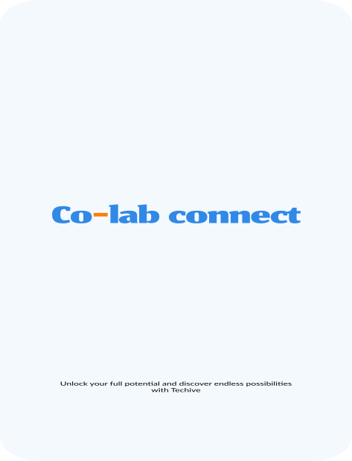 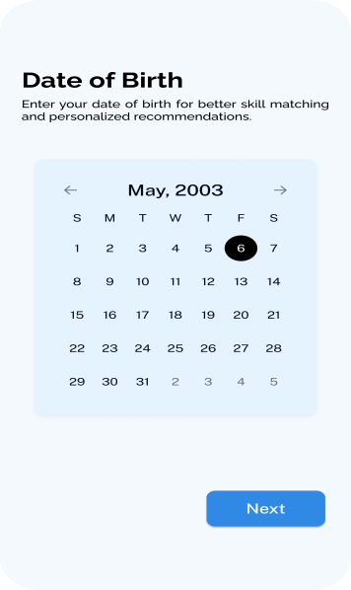 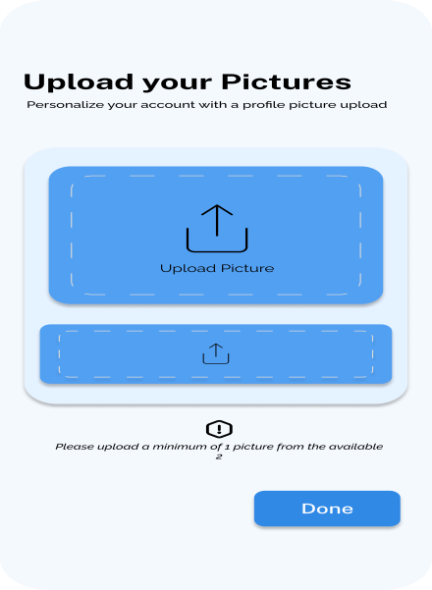

### **2. Create Account Screen**

**Purpose**: Allow new users to create an account.

#### **Content Details**:

* Fields:
  + Full Name.
  + Email Address.
  + Password.
  + Confirmation Password.
* CTA:
  + "Create Account" (Submit button).
  + "Already have an account? Log In."

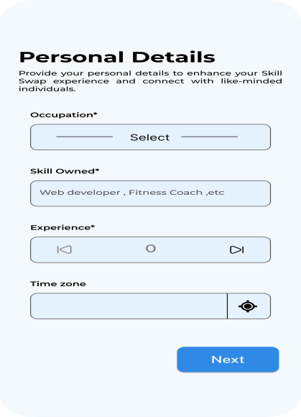 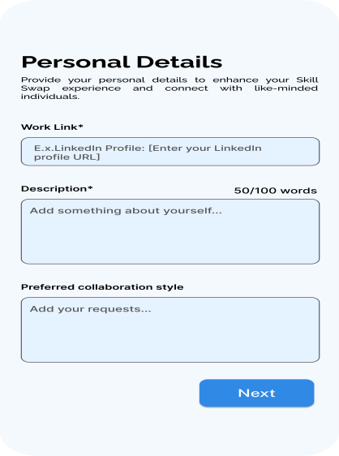

### **3. Home Screen**

**Purpose**: Provide a personalized dashboard with quick access to features.

#### **Content Details**:

* **Welcome Banner**:
  + Greeting: "Welcome back, [User's Name]!"
  + Suggested actions: "Find collaborators, start a project, or join the community."
* **Sections**:
  + Featured Posts: Display trending discussions or articles.
  + Navigation Tabs: Home, Matchmaking, Community, Chat.
* **CTA Buttons**:
  + "Find Collaborators."
  + "Explore Projects."

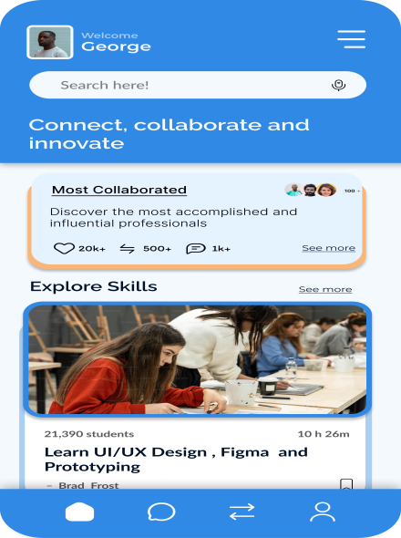 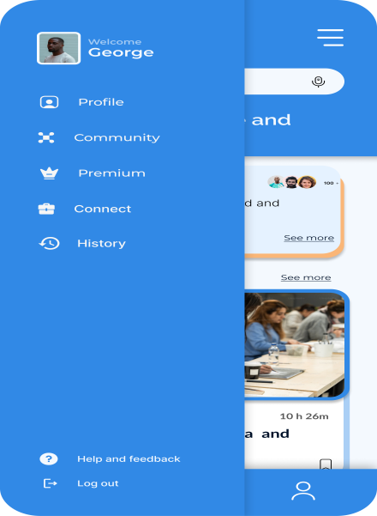

### **4. Matchmaking Screens**

**Purpose**: Facilitate AI-driven connections based on user preferences.

#### **Content Details**:

* **Matchmaking Search Screen**:
  + Filters:
    - Role: Co-founder, Mentor, Team Member.
    - Skills: Dropdown or tags for specific expertise.
    - Location: Remote, in-person, hybrid.
  + CTA: "Start Matching."
* **Matching Results**:
  + Profile cards:
    - Name, profile picture, skills, brief bio.
    - CTA: "View Profile" or "Send Request."

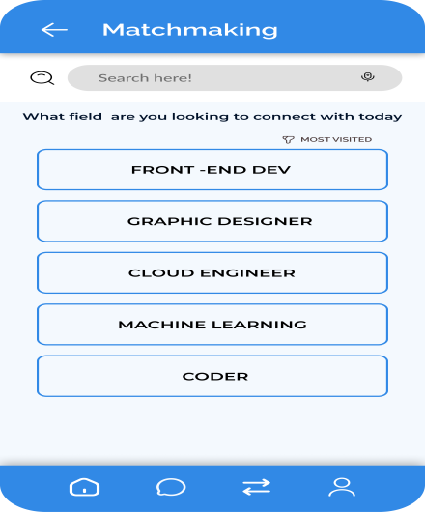 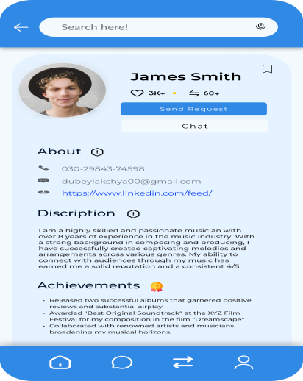

### **5. Community Screens**

**Purpose**: Enable user interaction through forums, Q&A, and discussions.

#### **Content Details**:

* **Community Dashboard**:
  + Categories:
    - Start-up advice, Fundraising tips, Product development.
  + Trending topics:
    - "Best practices for pitching to investors."
    - "How to build an MVP quickly."
* **Post Details Screen**:
  + Content:
    - Title, author, post content, and date.
    - Comments section: User comments with likes/replies.
  + CTA:
    - "Reply" or "Add Comment."

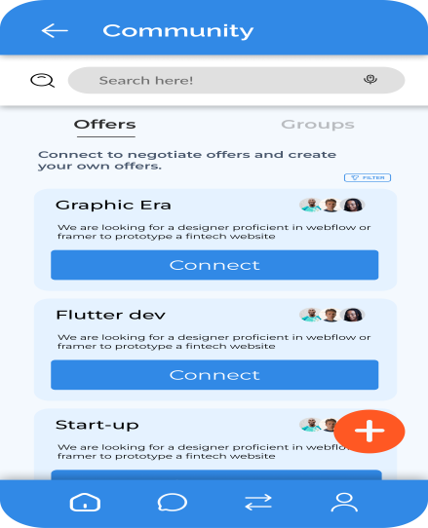 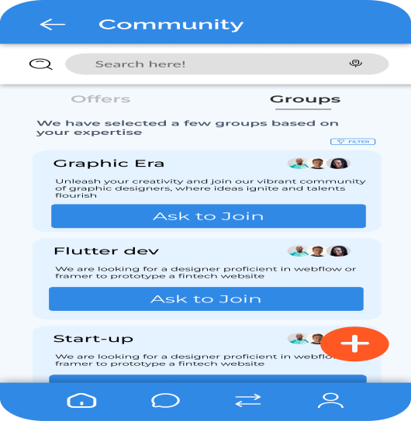

### **6. Chat Screens**

**Purpose**: Allow direct communication between users.

#### **Content Details**:

* **Chat List Screen**:
  + Display recent conversations:
    - Profile picture, name, last message, and timestamp.
  + CTA: "Start New Chat."
* **Individual Chat Screen**:
  + User messages with timestamps.
  + Input box:
    - "Type your message here…"
    - Send button (icon).

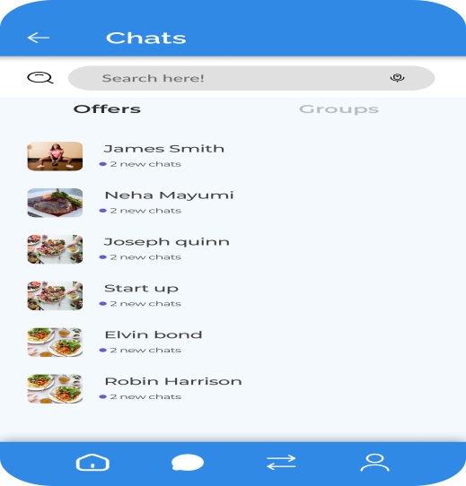 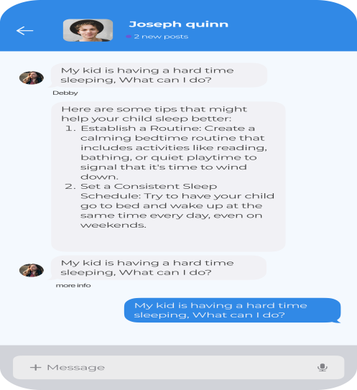

### **7. User Profile**

**Purpose**: Showcase user skills, goals, and availability.

#### **Content Details**:

* **Profile Sections**:
  + Basic Info: Name, bio, location.
  + Skills: Tags for technical and soft skills.
  + Current Goals: Example: "Looking for a full-stack developer."
  + Portfolio:
    - Links to GitHub, LinkedIn, or personal websites.

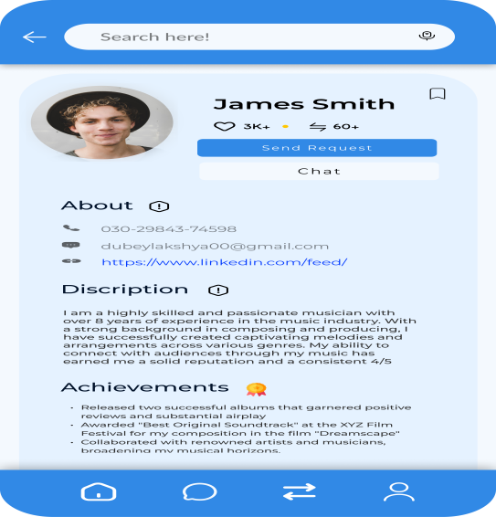

### **8. Skill Exchange Screen**

**Purpose**: Allow users to trade expertise with others.

#### **Content Details**:

* **Skill Listings**:
  + Example: "Offering coding mentorship in exchange for design expertise."
* **Post a Listing**:
  + Form fields:
    - Offered skills, Needed skills, Time commitment.
  + CTA: "Post Listing."

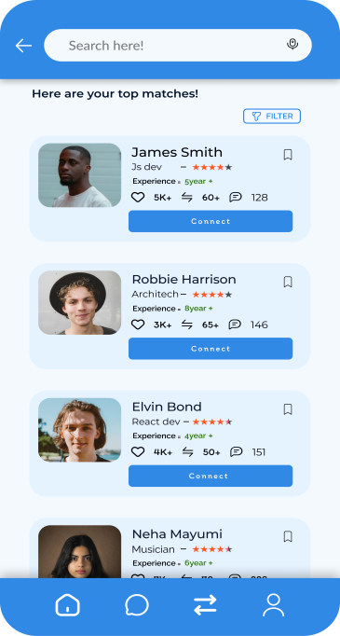 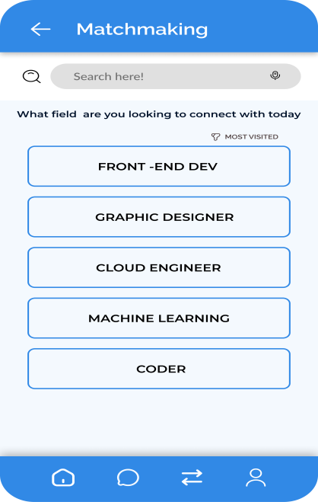

### **9. Navigation Footer**

**Purpose**: Provide quick access to core features.

#### **Tabs**:

1. **Home**.
2. **Matchmaking**.
3. **Community**.
4. **Chat**.
5. **Profile**.

# Prototypes (20 marks)

Kindly click on this link to access the Figma design “[Figma](https://www.figma.com/design/Xj2jtPWH2KdARyMjpox4UB/Untitled?node-id=208-2700&node-type=frame&t=INZ6isGRFuIrphgy-0)”.

Kindly click on this link to access the Prototype design “[Prototype](https://www.figma.com/proto/Xj2jtPWH2KdARyMjpox4UB/Untitled?page-id=0%3A1&node-id=206-2327&node-type=frame&t=INZ6isGRFuIrphgy-0&scaling=scale-down&content-scaling=fixed&starting-point-node-id=205%3A861&show-proto-sidebar=1)”

# Class Diagram (20 marks)

# Implementation - Developing the Agile Plan (20 marks)

# Conclusion

In conclusion, Co-Lab Connect provides a ground-breaking answer to one of the biggest problems that tech entrepreneurs are currently facing: efficient networking and cooperation. This platform enables start-ups to develop better teams and achieve sustainable growth by combining AI matchmaking, powerful project management tools, and a dynamic skill exchange system.  
  
The platform may be expanded in the future to include:  
sophisticated analytics to monitor individual contributions and project success.  
collaborations with academic institutions to offer certification and training courses.  
Improved funding prospects thanks to characteristics that match investors.

Co-Lab Connect essentially creates an end-to-end ecosystem that is customized to meet the specific requirements of tech entrepreneurs, going beyond conventional networking platforms. It not only fits with the idea of helping high-tech startups, but it also offers a basis for creativity and cooperation in the larger corporate environment.

# Team Contributions

|  |  |
| --- | --- |
| **Team Members** | **Content covered** |
| Chiagozie, Maduemesi | Introduction, Brainstorming, Features and Conclusion |
| Faith, Okunola | Personas, Descriptions, Web Analysis, Technical Requirement |
| Onolemen, Omokhuale | Forming Development Team, Content plans and prototype. |
| Shresta, Rapol | use cases , ER diagram, Activity diagram, class diagram, Developing Agile Plan excel sheet |

# References